Combining random variable

Binomial calculation can be approximated with a normal using

µ=np σ=square root of npq

***If both np and n(1-p) are at least 10.***

**Linear combinations of random variables**

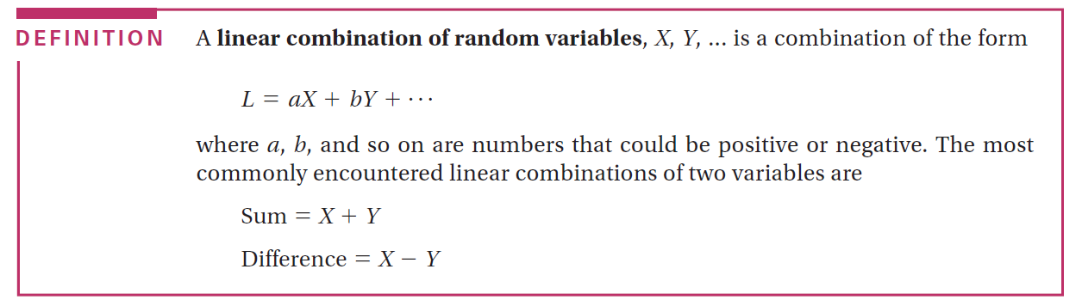

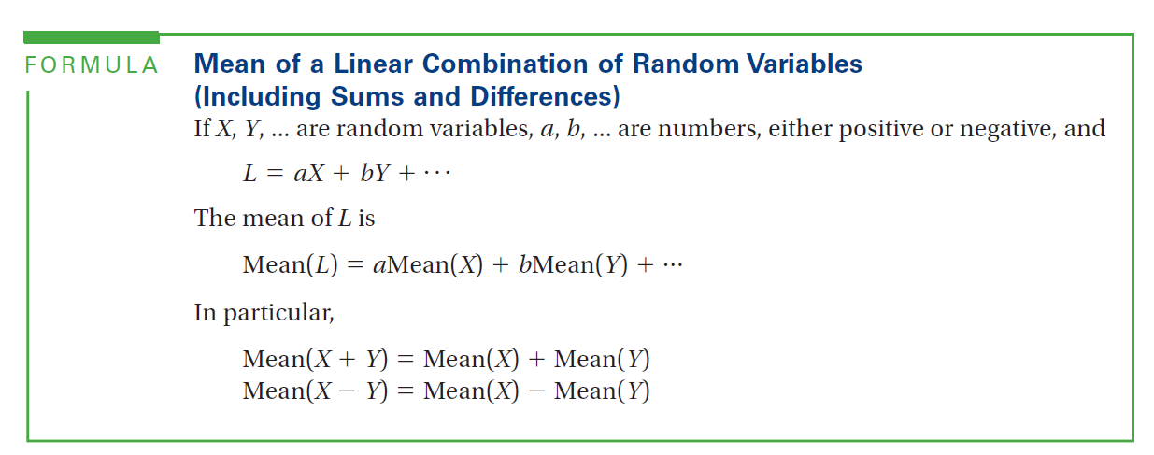

**\*no conditions**

E(X±Y)=E(X)±E(Y)

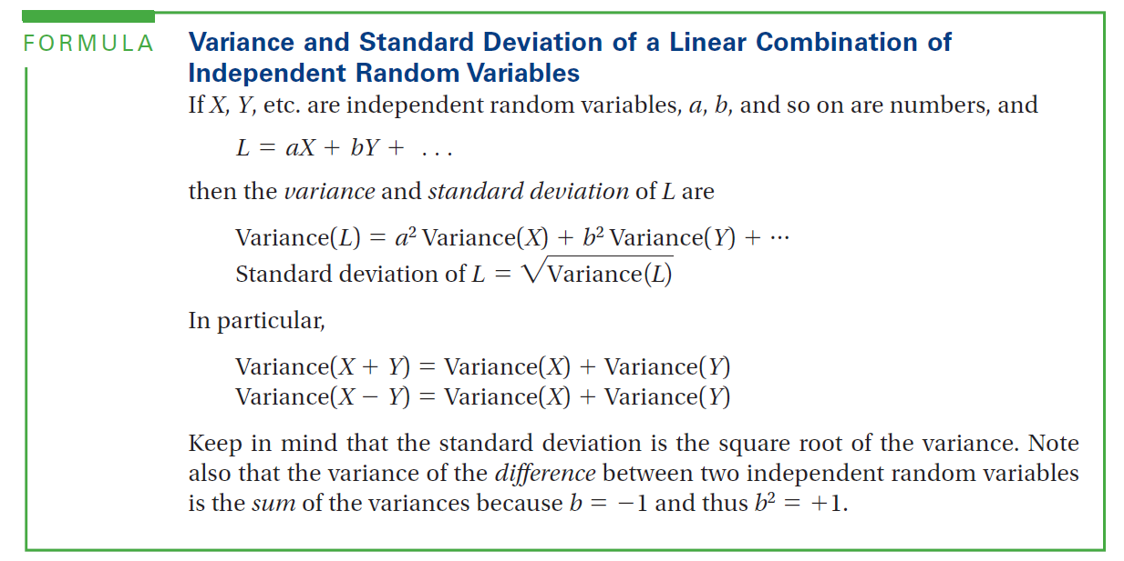

* ***IF X, Y… are STATISTICALLY INDEPENDENT\*\*\*\*\*\*\*\*\****

Variance of x and variance of y always add up***

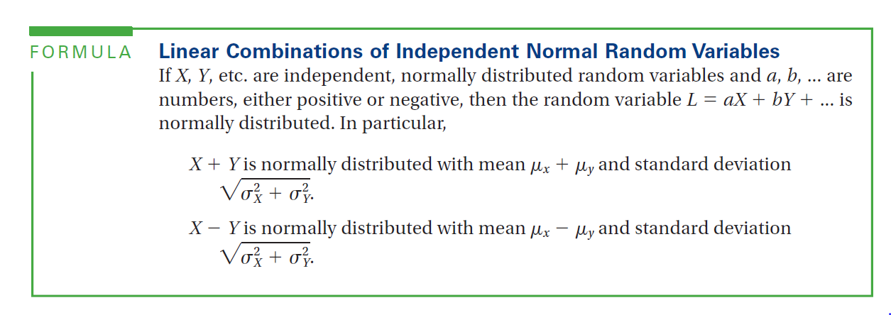

*****variance of X+Y and X-Y when X, Y are normal, are the same.